- Decrypt me if possible : Im a Ceaser
“ Upjl tllapun fvb! “
- Crack me if you can : I belong to MD5 family
67881381dbc68d4761230131ae0008f7
3. How Secure is my password?
R0ckY0u!R0ckY0u! (How long would it take a computer to crack my password?)
4. Can u help me get the secret is my audio file ?
BabyElephantWalk60 (1) - Attached in questions folder
5. Get my password if you can telnet-cooked (1) in this packet
6. Get my hidden password in my favourite picture
Attchment : Coversteg
7. Decode : birds on the wire
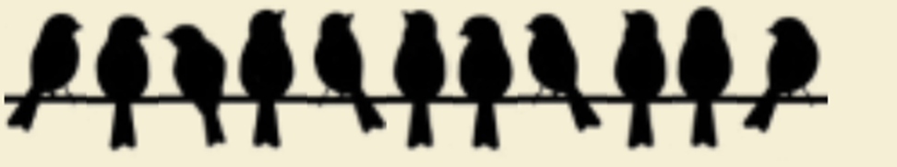

8. How severe my vulnerability is?
CVSS:3.1/AV:N/AC:L/PR:N/UI:N/S:C/C:H/I:H/A:H
9. Which special character is used to test if my application is vulnerable to sql injection? Mention that special character in hex decimal value
10. L0v3S3cUr!t% - what is this language called?

11. How many hosts are live in 81.22.234.0 subnet and which host has the open port of 8080?

12. Who Am i? (OSINT)
“Santhya Rajendran” received an award from “Indian Achievers Award”, under which category?
Hint : Webmii

13. Which type of social engineering attack can be performed to target the employees of Aristocrat?

14. Create a dictionary of atm pin number and tell me which pin number belongs to serial number 123 ?

15. What is the name of the possible attack using the below image
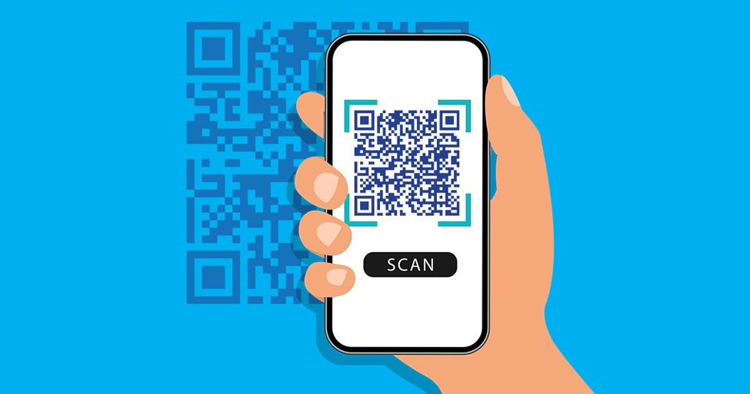

16 . Can u help me to find the unique id of this image? (EXIF ME)
Attachment : Olympus.jpg

17. What’s the username/password for the account? Rhino Hunt
Case : https://samsclass.info/121/proj/F201.htm

